Table of Contents

Key Management Issues 2

Key spaces 2

Key Generation 3

Key Storage 3

Session Key Establishment 3

Key agreement 3

Key Transportation 3

Entity and key authentication 3

Key Freshness 4

Diffie-Hellman Protocol 4

Initial Condition 4

Protocol 4

4

Man-in-the-middle attack vulnerability 4

5

Approach (1) solution 5

Approach (2) solution 5

Approach 1 VS Approach 2 6

6

Needham-Schroeder Protocol 6

# Key Management Issues

* This involves issues relating to **storing**, **strengthening keys**, **delivery**, **agreement of keys** and **revoking and replacement** of keys.
* Need to keep **symmetrical keys** secret.
* Need to confirm that **public keys** belong to who we think it they belong to.

## Key spaces

* This table shows that as the **key space increases** in size the **number of possible keys also increases** in size.
* Increases difficulty of revealing key by **brute-force.**
* **Increasing the number of bytes** of the key **increases the number of possible keys** also.
* Keep in mind that **computing power approximately doubles every 18 months** when choosing a key.
* **Making passwords random e.g. 430in6!23 rather than common and guessable e.g. D.O.B** also increases difficulty of revelation by brute-force.



## Key Generation

* Good keys are random numbers.
* Java.util.Random
* Cryptographically secure pseudo random number generator: SecureRandom class in java.security package.
* **Random number definition**: Given an integer, k >0, and a sequence of numbers, n1, n2, ..., an observer cannot predict nk even if all of n1, ..., nk-1 are known. The previous number/numbers cannot determine the next.
* **Physical sources of random numbers: atmospheric noise, stock market data.** These are non-deterministic.
* **Pseudo random numbers** can be generated from a **strong mixing function. Mixing function** takes 2 or more random inputsbased on **CPU load, arrival times of packets etc.** Each bit of the output then depends on some non-linear function of all the bits in the inputs.
* **Cryptographic hashing functions and encryption algorithms** are examples of **strong mixing functions.**

## Key Storage

* Try not to store key on a medium connected to the network.
* Key should never be unencrypted outside the encryption device.
* Use a physical token to store the key (e.g. smart card) and protect the token with a PIN number.
* Card can be stolen therefore store one half on the key in the machine and one half on the card.

## Session Key Establishment

* **A symmetric key is more likely to be broken** as the more times it is used, the more times it is brought into the memory which can be hacked. And the more ciphertexts are produced using it.
* Thus, create a **symmetric key for one session** only which is known as a **session key**.
* Using session keys, prevents the long-term storage of possibly many symmetric keys.

### Key agreement

* **Both parties contribute to the derivation of the shared secret** so that not party can pre-determine the resulting value. This is namely the **Diffie-Hellman protocol. What is the problem with one party generating the secret key?**

### Key Transportation

* **Without public-key cipher**: Session keys are generated and distributed with the help of **a third party**. Known as **Needham-Schroeder protocol**.
* **With the use of a public key cipher: One party** creates a secret key (session key), and securely transfers it to the other party using the **recipient’s public key.**

### Entity and key authentication

* Make sure no other party could gain access to the key.
* Confirm that the other party knows about the key by producing a one-way hash of the key or, encrypting some known data (e.g. nonce) with the key.
* Key freshness: make sure the key is fresh i.e. not been used before.

### Key Freshness

* Check if the key has not been used before.

# Diffie-Hellman Protocol

* Key-agreement protocol
* Public key algorithm
* Allows two parties who have **never met before** to exchange messages in public and **collectively generate a key** that is private to them.
* Security is based on the difficulty of calculating **discrete logs** in the finite field.
* Given integers y and g and prime number n, compute x such that y = g^x mod n

## Initial Condition

* Alice and Bob, agree on two large integers **g** and **n.**
* G and n do not have to be a secret.
* Alice has a private key Xa and public key Ya.
* Bob has a private key Xb and public key Yb.

## Protocol

# 

* This protocol resists passive attacks because calculating a **discrete logarithm** is a **computationally hard problem**.

## Man-in-the-middle attack vulnerability

* The receiver of the other half of the key does not know who it is coming from, so this is vulnerable to a **man-in-the-middle-attack.**

# 

* Alice and Bob actually share a key with Eve, rather than with each other.
* But, if Alice and Bob do not share a key then how do they encrypt the message? I guess they cannot.

## Approach (1) solution

## Approach (2) solution



## Approach 1 VS Approach 2

# 

# Needham-Schroeder Protocol

* Key distribution protocol

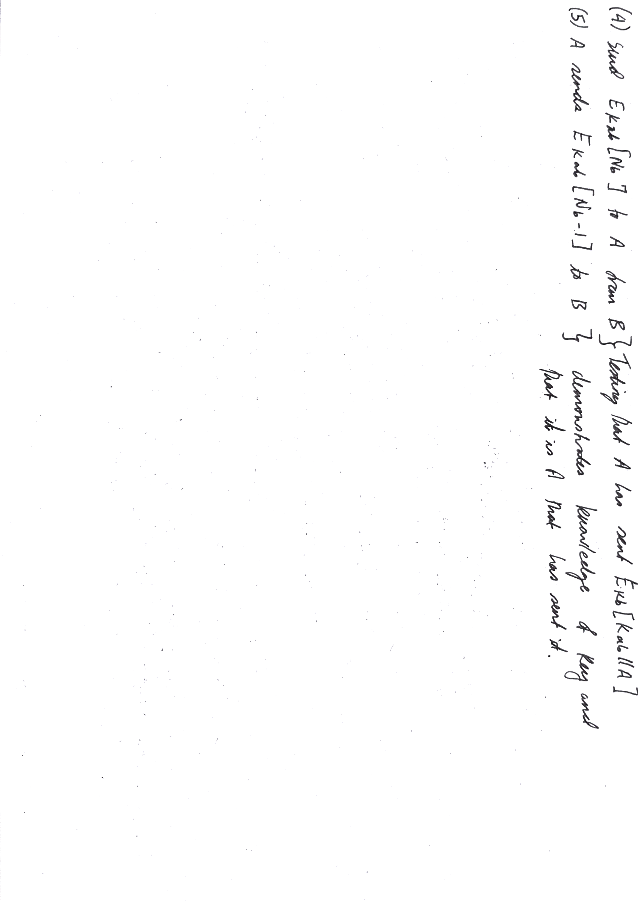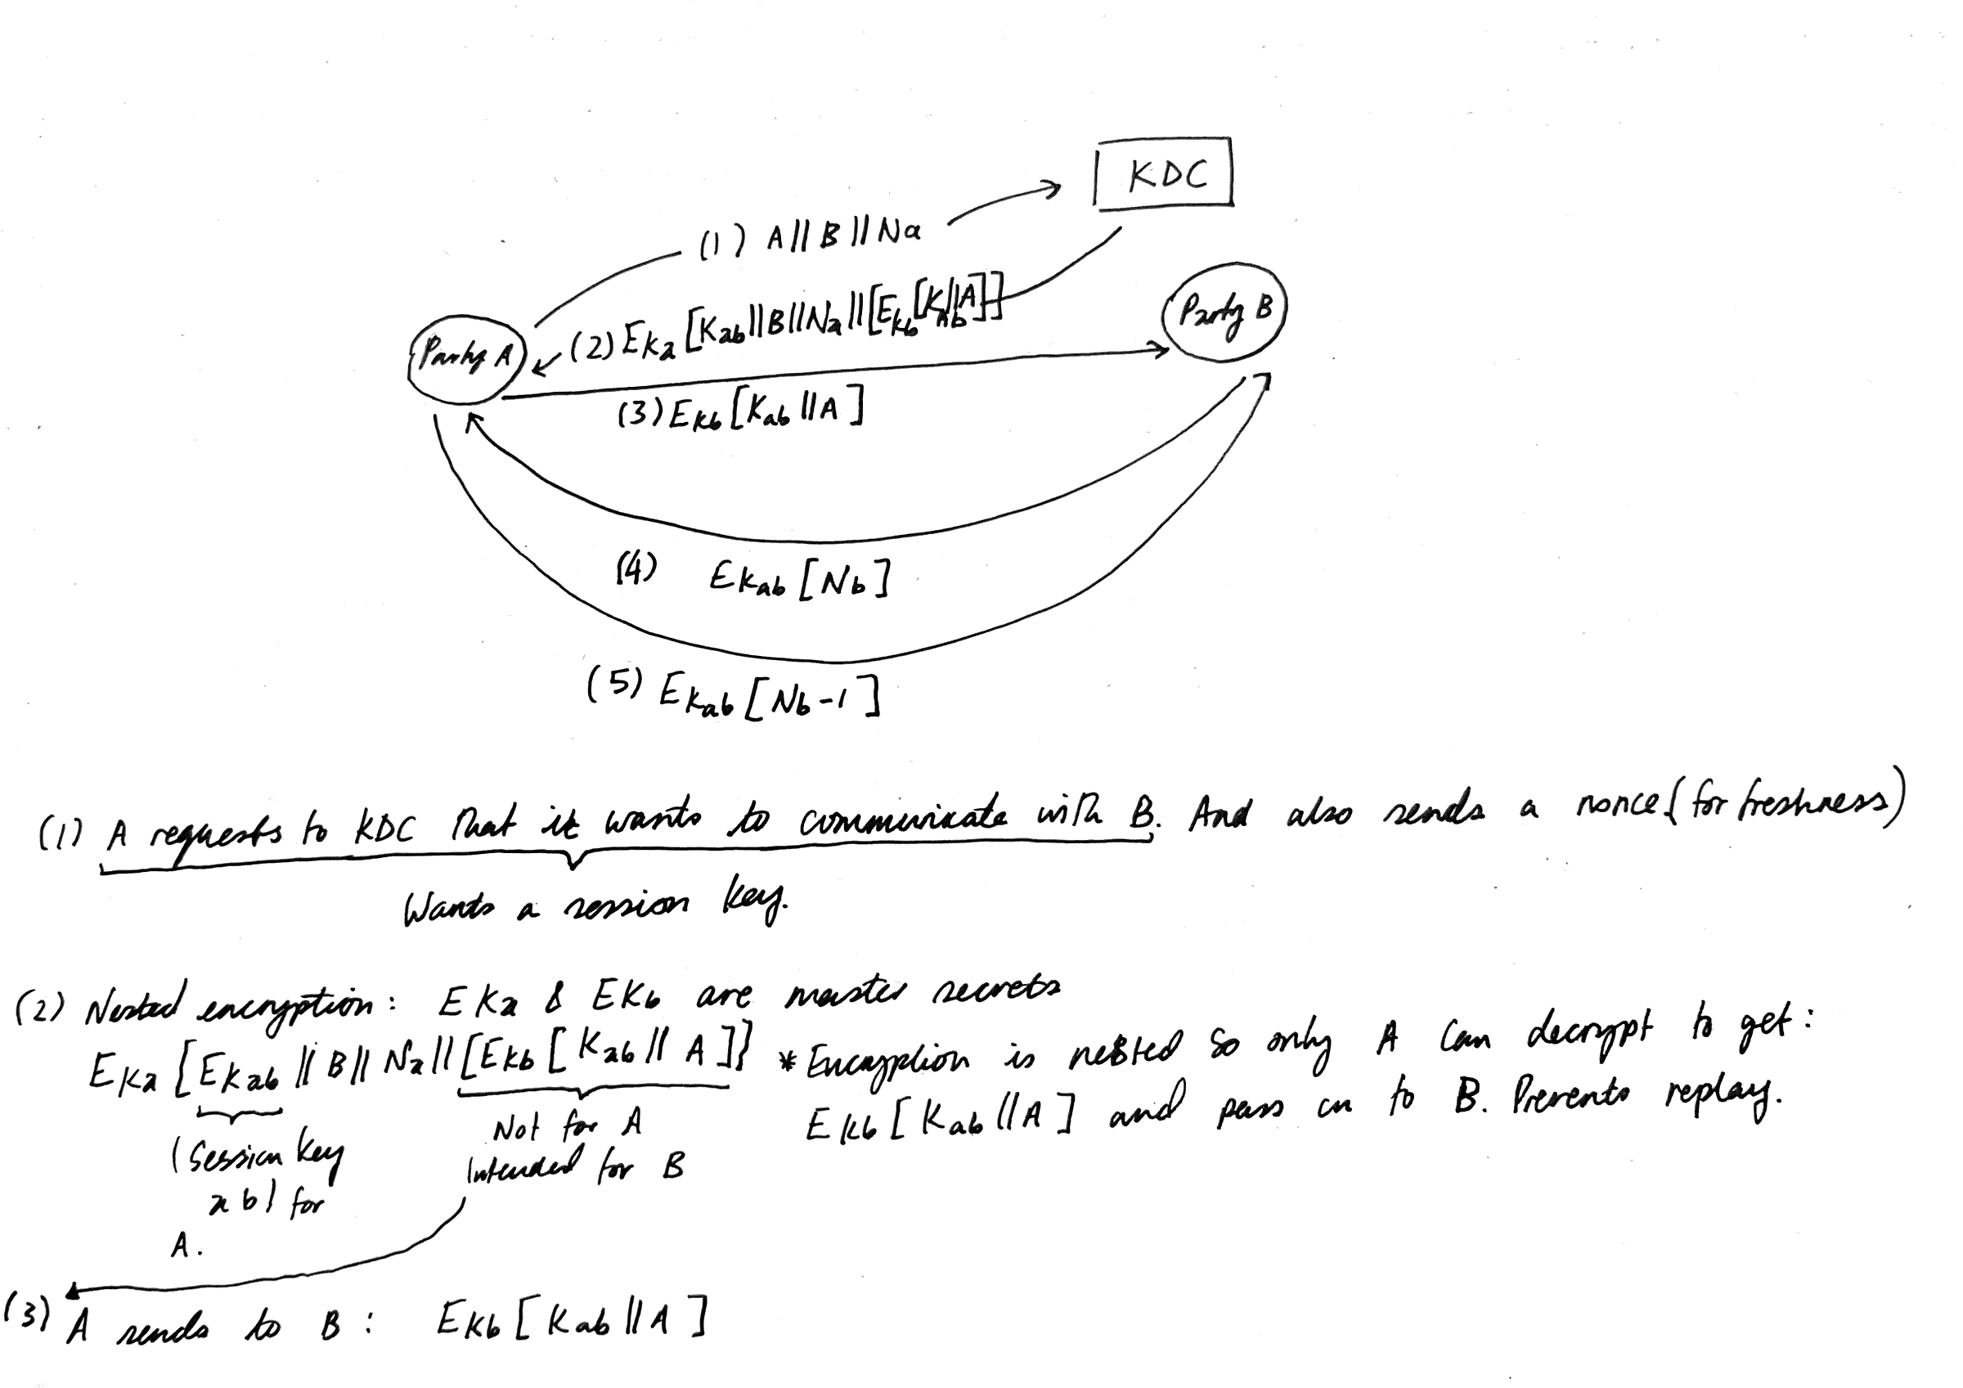

Nested encryption in step 3 is not necessary if you have steps 4 and 5.

Question: I don’t understand how step 3 would affect B, if it was a replay.

## Distribution using PKC



* Need to do authentication before key distribution
* Alice encrypts timestamp with her private key and who she is and who she wants to talk to.
* Bob generates the session key and encrypts with his private key along with the timestamp, and his identity and who he wants to talk to. He also sends his public key.